CSE 408

Homework 03

Austin Spencer

Nov 4th, 2021

1. Visually similar images:
   1. ***Image1***
   2. ***Image2***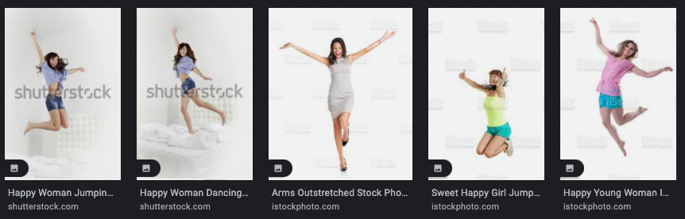
   3. ***Image3***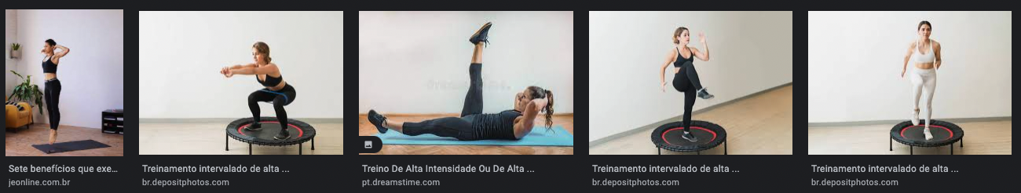
   4. ***Image4***
   5. Discussion: I think what’s being done is Google takes the image and extracts pieces from the image that are recognizable and uses those to search for similar images. This can work well for some but not as well for others. In these examples, Image3 was the best at generating similar images but still the original seemed to be more for showing off the smart clothing. The image4 was the worst I believe since the original had a couple of what looked like alcoholic drinks but the similar images was just fruit dishes.
2. Image editing
   1. ***Image1 – Adding noise***
   2. ***Image2 – Reduce saturation by 20%***
   3. ***Image3 – Increase sharpness by 15%***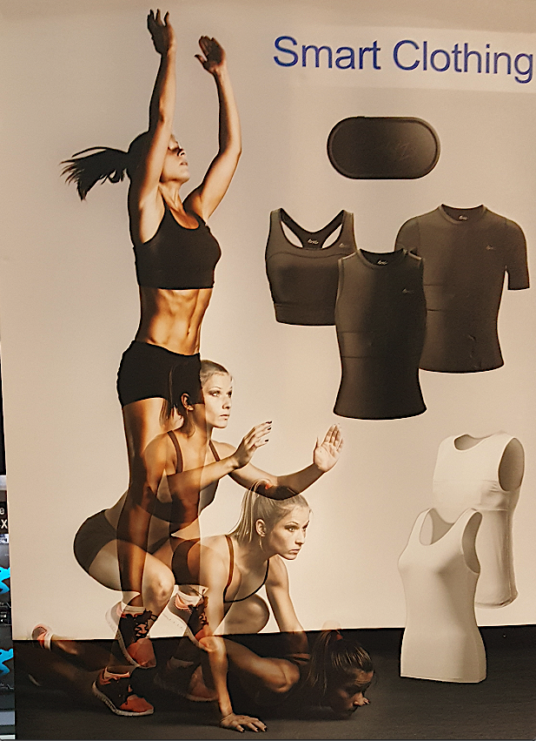
   4. ***Image 4 – Compress to 1/5 original size***

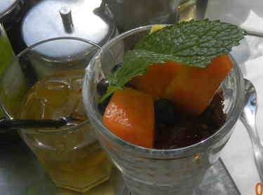

* 1. Search Results

|  |  |  |  |  |
| --- | --- | --- | --- | --- |
|  | Image1 | Image2 | Image3 | Image4 |
| # Results Original | 100+ | 100+ | 100+ | 100+ |
| # Results New | 4 | 2 | 7 | 2 |

1. Self-generated captions
   1. ***Image1*** – Artistic photos in a circle with stripes in the middle
      1. These results are much worse compared with the image search in part 1
   2. ***Image2*** – Woman with white background sitting on ground with VR goggles
      1. These results didn’t quite all look as similar as the image search in part one but were more similar images since it was all girls with vr goggles on sitting on the ground.
   3. ***Image3*** – Smart clothing girl working out doing burpees
      1. These results were not as good as the results from the image search in part 1.
   4. ***Image4*** – Low quality alcoholic drinks with fruits on the top
      1. These results still weren’t very similar to the original but more similar since we are now seeing drinks with fruit on top rather than just cups of fruit.
2. Auto-generated Tagging
   1. ***Image1*** –
      1. Tags: Parasol umbrella canopy shelter architecture design old pattern protective covering building
      2. The auto-generated tags don’t have a single word in common with my caption
      3. Conceptual similarity was pretty good if we look at the WUP table generated on WS4J demo. We can see that Artistic was not a good word but photos was similar to most of the other, Circle was most similar to building, stripes was similar to design and pattern while middle was closes to design and pattern as well.

|  |  |  |  |  |  |  |  |  |  |  |
| --- | --- | --- | --- | --- | --- | --- | --- | --- | --- | --- |
|  | **Artistic /JJ** | **photos /NNS** | **in /IN** | **a /DT** | **circle /NN** | **with /IN** | **stripes /NNS** | **in /IN** | **the /DT** | **middle /NN** |
| **Parasol/NNP** | - | [0.6316](https://ws4jdemo.appspot.com/?w1=photo%23n%231&w2=parasol%23n%231&measure=wup&mode=w) | - | - | [0.5714](https://ws4jdemo.appspot.com/?w1=circle%23n%238&w2=parasol%23n%231&measure=wup&mode=w) | - | [0.6316](https://ws4jdemo.appspot.com/?w1=stripe%23n%231&w2=parasol%23n%231&measure=wup&mode=w) | - | - | [0.4444](https://ws4jdemo.appspot.com/?w1=middle%23n%231&w2=parasol%23n%231&measure=wup&mode=w) |
| **umbrella/NN** | - | [0.6000](https://ws4jdemo.appspot.com/?w1=photo%23n%231&w2=umbrella%23n%231&measure=wup&mode=w) | - | - | [0.6957](https://ws4jdemo.appspot.com/?w1=circle%23n%234&w2=umbrella%23n%233&measure=wup&mode=w) | - | [0.6000](https://ws4jdemo.appspot.com/?w1=stripe%23n%231&w2=umbrella%23n%231&measure=wup&mode=w) | - | - | [0.4211](https://ws4jdemo.appspot.com/?w1=middle%23n%231&w2=umbrella%23n%231&measure=wup&mode=w) |
| **canopy/NN** | - | [0.7059](https://ws4jdemo.appspot.com/?w1=photo%23n%231&w2=canopy%23n%231&measure=wup&mode=w) | - | - | [0.6316](https://ws4jdemo.appspot.com/?w1=circle%23n%238&w2=canopy%23n%231&measure=wup&mode=w) | - | [0.7059](https://ws4jdemo.appspot.com/?w1=stripe%23n%231&w2=canopy%23n%231&measure=wup&mode=w) | - | - | [0.5000](https://ws4jdemo.appspot.com/?w1=middle%23n%231&w2=canopy%23n%231&measure=wup&mode=w) |
| **shelter/NN** | - | [0.7059](https://ws4jdemo.appspot.com/?w1=photo%23n%231&w2=shelter%23n%231&measure=wup&mode=w) | - | - | [0.7273](https://ws4jdemo.appspot.com/?w1=circle%23n%234&w2=shelter%23n%234&measure=wup&mode=w) | - | [0.7059](https://ws4jdemo.appspot.com/?w1=stripe%23n%231&w2=shelter%23n%231&measure=wup&mode=w) | - | - | [0.5000](https://ws4jdemo.appspot.com/?w1=middle%23n%231&w2=shelter%23n%231&measure=wup&mode=w) |
| **architecture/NN** | - | [0.6667](https://ws4jdemo.appspot.com/?w1=photo%23n%231&w2=architecture%23n%231&measure=wup&mode=w) | - | - | [0.6000](https://ws4jdemo.appspot.com/?w1=circle%23n%238&w2=architecture%23n%231&measure=wup&mode=w) | - | [0.6667](https://ws4jdemo.appspot.com/?w1=stripe%23n%231&w2=architecture%23n%231&measure=wup&mode=w) | - | - | [0.6316](https://ws4jdemo.appspot.com/?w1=middle%23n%232&w2=architecture%23n%232&measure=wup&mode=w) |
| **design/NN** | - | [0.8000](https://ws4jdemo.appspot.com/?w1=photo%23n%231&w2=design%23n%236&measure=wup&mode=w) | - | - | [0.6316](https://ws4jdemo.appspot.com/?w1=circle%23n%238&w2=design%23n%234&measure=wup&mode=w) | - | [0.8889](https://ws4jdemo.appspot.com/?w1=stripe%23n%235&w2=design%23n%234&measure=wup&mode=w) | - | - | [0.7368](https://ws4jdemo.appspot.com/?w1=middle%23n%232&w2=design%23n%233&measure=wup&mode=w) |
| **old/JJ** | - | - | - | - | - | - | - | - | - | - |
| **pattern/NN** | - | [0.7059](https://ws4jdemo.appspot.com/?w1=photo%23n%231&w2=pattern%23n%233&measure=wup&mode=w) | - | - | [0.6316](https://ws4jdemo.appspot.com/?w1=circle%23n%234&w2=pattern%23n%232&measure=wup&mode=w) | - | [0.8889](https://ws4jdemo.appspot.com/?w1=stripe%23n%235&w2=pattern%23n%233&measure=wup&mode=w) | - | - | [0.7368](https://ws4jdemo.appspot.com/?w1=middle%23n%232&w2=pattern%23n%236&measure=wup&mode=w) |
| **protective/JJ** | - | - | - | - | - | - | - | - | - | - |
| **covering/VBG** | - | - | - | - | - | - | - | - | - | - |
| **building/NN** | - | [0.7059](https://ws4jdemo.appspot.com/?w1=photo%23n%231&w2=building%23n%231&measure=wup&mode=w) | - | - | [0.7692](https://ws4jdemo.appspot.com/?w1=circle%23n%232&w2=building%23n%234&measure=wup&mode=w) | - | [0.7059](https://ws4jdemo.appspot.com/?w1=stripe%23n%231&w2=building%23n%231&measure=wup&mode=w) | - | - | [0.5000](https://ws4jdemo.appspot.com/?w1=middle%23n%231&w2=building%23n%231&measure=wup&mode=w) |

* 1. ***Image2*** –
     1. Tags: attractive person adult pretty people fashion happy smile portrait dancer
     2. Again not a single word is the same but this time I had woman and the auto-tagging had person and people so I would say that’s similar.
     3. The conceptual similarity between human and auto-generated captions wasn’t as good for image2. Looking at the table we can see that Woman and background were the only two words that had decent scores for WUP and VR even got -1 for most.

|  |  |  |  |  |  |  |  |  |  |  |
| --- | --- | --- | --- | --- | --- | --- | --- | --- | --- | --- |
|  | **Woman /NN** | **with /IN** | **white /JJ** | **background /NN** | **sitting /VBG** | **on /IN** | **ground /NN** | **with /IN** | **VR /NNP** | **goggles /NNS** |
| **attractive/JJ** | - | - | - | - | - | - | - | - | - | - |
| **person/NN** | [0.8889](https://ws4jdemo.appspot.com/?w1=woman%23n%231&w2=person%23n%231&measure=wup&mode=w) | - | - | [0.5263](https://ws4jdemo.appspot.com/?w1=background%23n%238&w2=person%23n%231&measure=wup&mode=w) | - | - | [0.6250](https://ws4jdemo.appspot.com/?w1=ground%23n%2310&w2=person%23n%231&measure=wup&mode=w) | - | [-1](https://ws4jdemo.appspot.com/?w1=vr%23n&w2=person%23n&measure=wup&mode=w) | [0.5000](https://ws4jdemo.appspot.com/?w1=goggles%23n%231&w2=person%23n%231&measure=wup&mode=w) |
| **adult/NN** | [0.9474](https://ws4jdemo.appspot.com/?w1=woman%23n%231&w2=adult%23n%231&measure=wup&mode=w) | - | - | [0.5000](https://ws4jdemo.appspot.com/?w1=background%23n%238&w2=adult%23n%231&measure=wup&mode=w) | - | - | [0.5882](https://ws4jdemo.appspot.com/?w1=ground%23n%2310&w2=adult%23n%231&measure=wup&mode=w) | - | [-1](https://ws4jdemo.appspot.com/?w1=vr%23n&w2=adult%23n&measure=wup&mode=w) | [0.4762](https://ws4jdemo.appspot.com/?w1=goggles%23n%231&w2=adult%23n%231&measure=wup&mode=w) |
| **pretty/JJ** | - | - | - | - | - | - | - | - | - | - |
| **people/NNS** | [0.8333](https://ws4jdemo.appspot.com/?w1=woman%23n%234&w2=people%23n%231&measure=wup&mode=w) | - | - | [0.5455](https://ws4jdemo.appspot.com/?w1=background%23n%231&w2=people%23n%231&measure=wup&mode=w) | - | - | [0.5455](https://ws4jdemo.appspot.com/?w1=ground%23n%234&w2=people%23n%231&measure=wup&mode=w) | - | [-1](https://ws4jdemo.appspot.com/?w1=vr%23n&w2=people%23n&measure=wup&mode=w) | [0.2353](https://ws4jdemo.appspot.com/?w1=goggles%23n%231&w2=people%23n%231&measure=wup&mode=w) |
| **fashion/NN** | [0.5263](https://ws4jdemo.appspot.com/?w1=woman%23n%231&w2=fashion%23n%234&measure=wup&mode=w) | - | - | [0.6667](https://ws4jdemo.appspot.com/?w1=background%23n%231&w2=fashion%23n%231&measure=wup&mode=w) | - | - | [0.7059](https://ws4jdemo.appspot.com/?w1=ground%23n%2310&w2=fashion%23n%234&measure=wup&mode=w) | - | [-1](https://ws4jdemo.appspot.com/?w1=vr%23n&w2=fashion%23n&measure=wup&mode=w) | [0.5714](https://ws4jdemo.appspot.com/?w1=goggles%23n%231&w2=fashion%23n%234&measure=wup&mode=w) |
| **happy/JJ** | - | - | - | - | - | - | - | - | - | - |
| **smile/NN** | [0.4000](https://ws4jdemo.appspot.com/?w1=woman%23n%234&w2=smile%23n%231&measure=wup&mode=w) | - | - | [0.4286](https://ws4jdemo.appspot.com/?w1=background%23n%231&w2=smile%23n%231&measure=wup&mode=w) | - | - | [0.4286](https://ws4jdemo.appspot.com/?w1=ground%23n%234&w2=smile%23n%231&measure=wup&mode=w) | - | [-1](https://ws4jdemo.appspot.com/?w1=vr%23n&w2=smile%23n&measure=wup&mode=w) | [0.2000](https://ws4jdemo.appspot.com/?w1=goggles%23n%231&w2=smile%23n%231&measure=wup&mode=w) |
| **portrait/NN** | [0.4762](https://ws4jdemo.appspot.com/?w1=woman%23n%231&w2=portrait%23n%232&measure=wup&mode=w) | - | - | [0.7273](https://ws4jdemo.appspot.com/?w1=background%23n%238&w2=portrait%23n%232&measure=wup&mode=w) | - | - | [0.6316](https://ws4jdemo.appspot.com/?w1=ground%23n%2310&w2=portrait%23n%232&measure=wup&mode=w) | - | [-1](https://ws4jdemo.appspot.com/?w1=vr%23n&w2=portrait%23n&measure=wup&mode=w) | [0.5217](https://ws4jdemo.appspot.com/?w1=goggles%23n%231&w2=portrait%23n%232&measure=wup&mode=w) |
| **dancer/NN** | [0.8421](https://ws4jdemo.appspot.com/?w1=woman%23n%231&w2=dancer%23n%232&measure=wup&mode=w) | - | - | [0.5000](https://ws4jdemo.appspot.com/?w1=background%23n%238&w2=dancer%23n%232&measure=wup&mode=w) | - | - | [0.5882](https://ws4jdemo.appspot.com/?w1=ground%23n%2310&w2=dancer%23n%232&measure=wup&mode=w) | - | [-1](https://ws4jdemo.appspot.com/?w1=vr%23n&w2=dancer%23n&measure=wup&mode=w) | [0.4762](https://ws4jdemo.appspot.com/?w1=goggles%23n%231&w2=dancer%23n%232&measure=wup&mode=w) |

* 1. ***Image3*** –
     1. Tags: clothing sexy lingerie brassiere body attractive covering model woman’s clothing undergarment
     2. It seems as though the auto-tagging was mostly focused on that the girl is wearing sports bra. Mine is similar where they mention woman’s clothing but nothing mentioned about working out in auto-tag
     3. This image the conceptual similarity between the tagging is very similar. As you can see from the graph most words were significantly similar. The only outlier is burpees which scores -1 for most.

|  |  |  |  |  |  |  |  |
| --- | --- | --- | --- | --- | --- | --- | --- |
|  | **Smart /JJ** | **clothing /NN** | **girl /NN** | **working /VBG** | **out /RP** | **doing /VBG** | **burpees /NNS** |
| **clothing/NN** | - | [1.0000](https://ws4jdemo.appspot.com/?w1=clothing%23n%231&w2=clothing%23n%231&measure=wup&mode=w) | [0.5556](https://ws4jdemo.appspot.com/?w1=girl%23n%232&w2=clothing%23n%231&measure=wup&mode=w) | - | - | - | [-1](https://ws4jdemo.appspot.com/?w1=burpee%23n&w2=clothing%23n&measure=wup&mode=w) |
| **sexy/JJ** | - | - | - | - | - | - | - |
| **lingerie/NN** | - | [0.8182](https://ws4jdemo.appspot.com/?w1=clothing%23n%231&w2=lingerie%23n%231&measure=wup&mode=w) | [0.4545](https://ws4jdemo.appspot.com/?w1=girl%23n%232&w2=lingerie%23n%231&measure=wup&mode=w) | - | - | - | [-1](https://ws4jdemo.appspot.com/?w1=burpee%23n&w2=lingerie%23n&measure=wup&mode=w) |
| **brassiere/NN** | - | [0.9000](https://ws4jdemo.appspot.com/?w1=clothing%23n%231&w2=brassiere%23n%231&measure=wup&mode=w) | [0.5000](https://ws4jdemo.appspot.com/?w1=girl%23n%232&w2=brassiere%23n%231&measure=wup&mode=w) | - | - | - | [-1](https://ws4jdemo.appspot.com/?w1=burpee%23n&w2=brassiere%23n&measure=wup&mode=w) |
| **body/NN** | - | [0.7500](https://ws4jdemo.appspot.com/?w1=clothing%23n%231&w2=body%23n%2311&measure=wup&mode=w) | [0.5882](https://ws4jdemo.appspot.com/?w1=girl%23n%232&w2=body%23n%231&measure=wup&mode=w) | - | - | - | [-1](https://ws4jdemo.appspot.com/?w1=burpee%23n&w2=body%23n&measure=wup&mode=w) |
| **attractive/JJ** | - | - | - | - | - | - | - |
| **covering/VBG** | - | - | - | [0.7500](https://ws4jdemo.appspot.com/?w1=work%23v%237&w2=cover%23v%237&measure=wup&mode=w) | - | [0.8333](https://ws4jdemo.appspot.com/?w1=do%23v%237&w2=cover%23v%234&measure=wup&mode=w) | - |
| **model/NN** | - | [0.7059](https://ws4jdemo.appspot.com/?w1=clothing%23n%231&w2=model%23n%234&measure=wup&mode=w) | [0.8000](https://ws4jdemo.appspot.com/?w1=girl%23n%232&w2=model%23n%236&measure=wup&mode=w) | - | - | - | [-1](https://ws4jdemo.appspot.com/?w1=burpee%23n&w2=model%23n&measure=wup&mode=w) |
| **woman’s/NNS** | - | [-1](https://ws4jdemo.appspot.com/?w1=clothing%23n&w2=woman%E2%80%99s%23n&measure=wup&mode=w) | [-1](https://ws4jdemo.appspot.com/?w1=girl%23n&w2=woman%E2%80%99s%23n&measure=wup&mode=w) | - | - | - | [-1](https://ws4jdemo.appspot.com/?w1=burpee%23n&w2=woman%E2%80%99s%23n&measure=wup&mode=w) |
| **clothing/NN** | - | [1.0000](https://ws4jdemo.appspot.com/?w1=clothing%23n%231&w2=clothing%23n%231&measure=wup&mode=w) | [0.5556](https://ws4jdemo.appspot.com/?w1=girl%23n%232&w2=clothing%23n%231&measure=wup&mode=w) | - | - | - | [-1](https://ws4jdemo.appspot.com/?w1=burpee%23n&w2=clothing%23n&measure=wup&mode=w) |
| **undergarment/NN** | - | [0.9000](https://ws4jdemo.appspot.com/?w1=clothing%23n%231&w2=undergarment%23n%231&measure=wup&mode=w) | [0.5000](https://ws4jdemo.appspot.com/?w1=girl%23n%232&w2=undergarment%23n%231&measure=wup&mode=w) | - | - | - | [-1](https://ws4jdemo.appspot.com/?w1=burpee%23n&w2=undergarment%23n&measure=wup&mode=w) |

* 1. ***Image4*** –
     1. Tags: food fruit edible fruit diet vegetable citrus fresh salad meal healthy
     2. These tags are similar to mine in the mentions of fruit and makes sense if Google images is using similar tagging to find visually similar images since there is no mention of drinks
     3. The conceptual similarity between the tagging for image4 was just alright. The table shows that there are a lot of hits that were not very significant in similarity. The only two that were very significant is fruits and drinks which were both > .93 with fruits being exact at 1.0.

|  |  |  |  |  |  |  |  |  |  |
| --- | --- | --- | --- | --- | --- | --- | --- | --- | --- |
|  | **Low /NNP** | **quality /NN** | **alcoholic /JJ** | **drinks /NNS** | **with /IN** | **fruits /NNS** | **on /IN** | **the /DT** | **top /NN** |
| **food/NN** | [0.4286](https://ws4jdemo.appspot.com/?w1=low%23n%233&w2=food%23n%233&measure=wup&mode=w) | [0.7059](https://ws4jdemo.appspot.com/?w1=quality%23n%233&w2=food%23n%233&measure=wup&mode=w) | - | [0.9231](https://ws4jdemo.appspot.com/?w1=drink%23n%233&w2=food%23n%231&measure=wup&mode=w) | - | [0.4706](https://ws4jdemo.appspot.com/?w1=fruit%23n%233&w2=food%23n%233&measure=wup&mode=w) | - | - | [0.6667](https://ws4jdemo.appspot.com/?w1=top%23n%234&w2=food%23n%233&measure=wup&mode=w) |
| **fruit/NN** | [0.6000](https://ws4jdemo.appspot.com/?w1=low%23n%234&w2=fruit%23n%232&measure=wup&mode=w) | [0.4000](https://ws4jdemo.appspot.com/?w1=quality%23n%231&w2=fruit%23n%233&measure=wup&mode=w) | - | [0.4545](https://ws4jdemo.appspot.com/?w1=drink%23n%232&w2=fruit%23n%233&measure=wup&mode=w) | - | [1.0000](https://ws4jdemo.appspot.com/?w1=fruit%23n%231&w2=fruit%23n%231&measure=wup&mode=w) | - | - | [0.7059](https://ws4jdemo.appspot.com/?w1=top%23n%238&w2=fruit%23n%232&measure=wup&mode=w) |
| **edible/NN** | [0.3529](https://ws4jdemo.appspot.com/?w1=low%23n%232&w2=edible%23n%231&measure=wup&mode=w) | [0.3333](https://ws4jdemo.appspot.com/?w1=quality%23n%231&w2=edible%23n%231&measure=wup&mode=w) | - | [0.8571](https://ws4jdemo.appspot.com/?w1=drink%23n%233&w2=edible%23n%231&measure=wup&mode=w) | - | [0.3750](https://ws4jdemo.appspot.com/?w1=fruit%23n%232&w2=edible%23n%231&measure=wup&mode=w) | - | - | [0.4286](https://ws4jdemo.appspot.com/?w1=top%23n%231&w2=edible%23n%231&measure=wup&mode=w) |
| **fruit/NN** | [0.6000](https://ws4jdemo.appspot.com/?w1=low%23n%234&w2=fruit%23n%232&measure=wup&mode=w) | [0.4000](https://ws4jdemo.appspot.com/?w1=quality%23n%231&w2=fruit%23n%233&measure=wup&mode=w) | - | [0.4545](https://ws4jdemo.appspot.com/?w1=drink%23n%232&w2=fruit%23n%233&measure=wup&mode=w) | - | [1.0000](https://ws4jdemo.appspot.com/?w1=fruit%23n%231&w2=fruit%23n%231&measure=wup&mode=w) | - | - | [0.7059](https://ws4jdemo.appspot.com/?w1=top%23n%238&w2=fruit%23n%232&measure=wup&mode=w) |
| **diet/NN** | [0.3750](https://ws4jdemo.appspot.com/?w1=low%23n%233&w2=diet%23n%232&measure=wup&mode=w) | [0.4286](https://ws4jdemo.appspot.com/?w1=quality%23n%231&w2=diet%23n%232&measure=wup&mode=w) | - | [0.8000](https://ws4jdemo.appspot.com/?w1=drink%23n%233&w2=diet%23n%231&measure=wup&mode=w) | - | [0.4545](https://ws4jdemo.appspot.com/?w1=fruit%23n%233&w2=diet%23n%234&measure=wup&mode=w) | - | - | [0.4000](https://ws4jdemo.appspot.com/?w1=top%23n%231&w2=diet%23n%231&measure=wup&mode=w) |
| **vegetable/NN** | [0.5833](https://ws4jdemo.appspot.com/?w1=low%23n%232&w2=vegetable%23n%232&measure=wup&mode=w) | [0.3077](https://ws4jdemo.appspot.com/?w1=quality%23n%231&w2=vegetable%23n%231&measure=wup&mode=w) | - | [0.5333](https://ws4jdemo.appspot.com/?w1=drink%23n%233&w2=vegetable%23n%231&measure=wup&mode=w) | - | [0.5000](https://ws4jdemo.appspot.com/?w1=fruit%23n%232&w2=vegetable%23n%232&measure=wup&mode=w) | - | - | [0.5263](https://ws4jdemo.appspot.com/?w1=top%23n%238&w2=vegetable%23n%232&measure=wup&mode=w) |
| **citrus/NN** | [0.5185](https://ws4jdemo.appspot.com/?w1=low%23n%232&w2=citrus%23n%232&measure=wup&mode=w) | [0.2857](https://ws4jdemo.appspot.com/?w1=quality%23n%231&w2=citrus%23n%231&measure=wup&mode=w) | - | [0.5000](https://ws4jdemo.appspot.com/?w1=drink%23n%233&w2=citrus%23n%231&measure=wup&mode=w) | - | [0.9091](https://ws4jdemo.appspot.com/?w1=fruit%23n%231&w2=citrus%23n%231&measure=wup&mode=w) | - | - | [0.5000](https://ws4jdemo.appspot.com/?w1=top%23n%238&w2=citrus%23n%231&measure=wup&mode=w) |
| **fresh/JJ** | - | - | - | - | - | - | - | - | - |
| **salad/NN** | [0.3158](https://ws4jdemo.appspot.com/?w1=low%23n%232&w2=salad%23n%231&measure=wup&mode=w) | [0.2857](https://ws4jdemo.appspot.com/?w1=quality%23n%231&w2=salad%23n%231&measure=wup&mode=w) | - | [0.7500](https://ws4jdemo.appspot.com/?w1=drink%23n%233&w2=salad%23n%231&measure=wup&mode=w) | - | [0.3333](https://ws4jdemo.appspot.com/?w1=fruit%23n%232&w2=salad%23n%231&measure=wup&mode=w) | - | - | [0.3750](https://ws4jdemo.appspot.com/?w1=top%23n%231&w2=salad%23n%231&measure=wup&mode=w) |
| **meal/NN** | [0.3750](https://ws4jdemo.appspot.com/?w1=low%23n%233&w2=meal%23n%232&measure=wup&mode=w) | [0.4286](https://ws4jdemo.appspot.com/?w1=quality%23n%231&w2=meal%23n%232&measure=wup&mode=w) | - | [0.8000](https://ws4jdemo.appspot.com/?w1=drink%23n%233&w2=meal%23n%231&measure=wup&mode=w) | - | [0.3529](https://ws4jdemo.appspot.com/?w1=fruit%23n%232&w2=meal%23n%231&measure=wup&mode=w) | - | - | [0.4000](https://ws4jdemo.appspot.com/?w1=top%23n%231&w2=meal%23n%231&measure=wup&mode=w) |
| **healthy/JJ** | - | - | - | - | - | - | - | - | - |